# **ER Diagram**

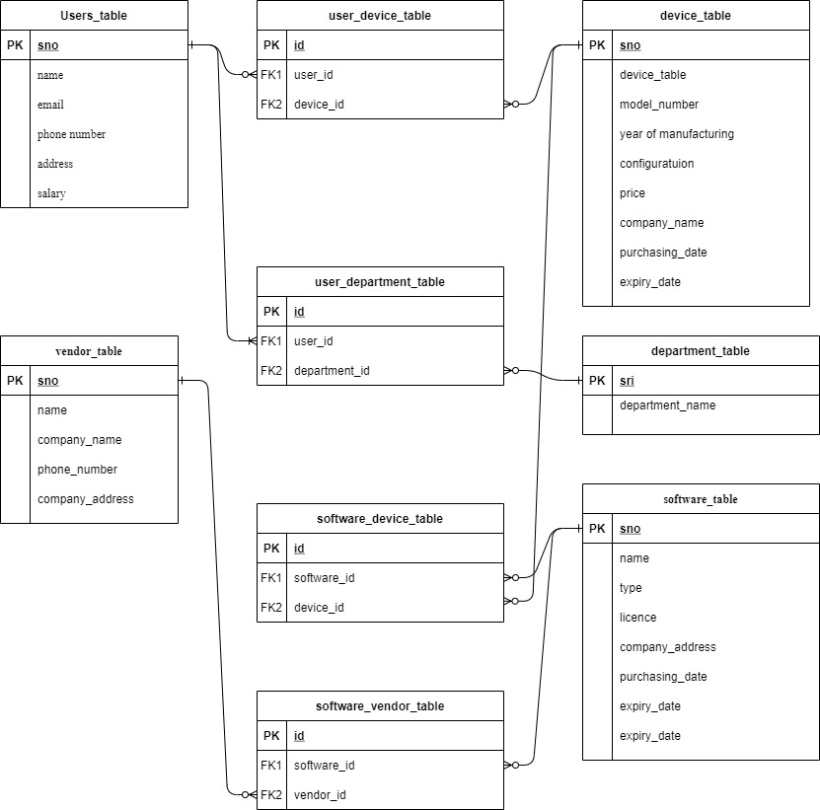

**Various Assumptions taken into account while create design of the database**

1. Device can be assigned to more than one user and the relation is created in user_device_table

2. Department can contain more than one user and the relation is created in user_departmenttable

3. More than one software can be installed on one device and the relation is created in software_device_table

4. One vendor can distribute more than one software and relation is created in software_vendor_table

# **SQL Commands**

**Create Queries**

CREATE Database newhill_mining_company;

USE newhill_mining_company;

**Department table with create Query**

CREATE TABLE department (

sri int(11) NOT NULL AUTO_INCREMENT PRIMARY KEY,

department_name varchar(255) NOT NULL

);

**Device Table with Create Query**

CREATE TABLE device_table (

sno int(11) NOT NULL AUTO_INCREMENT PRIMARY KEY,

device_type varchar(15) NOT NULL,

model_number varchar(50) NOT NULL,

year_of_manufacture datetime NOT NULL,

configuration varchar(255) NOT NULL,

price float NOT NULL,

company_name varchar(30) NOT NULL,

purchasing_date datetime NOT NULL,

expiry_date datetime NOT NULL

);

**Software Table with create Query**

CREATE TABLE software_table (

sno int(11) NOT NULL AUTO_INCREMENT PRIMARY KEY,

name varchar(50) NOT NULL,

type varchar(100) NOT NULL,

licence int(11) NOT NULL,

purchasing_date datetime NOT NULL,

expiry_date datetime NOT NULL,

no_of_copies int(11) NOT NULL

);

**User Table with create Query**

CREATE TABLE users_table (

sno int(11) NOT NULL AUTO_INCREMENT PRIMARY KEY,

name varchar(60) NOT NULL,

email_id varchar(60) NOT NULL,

phone_number varchar(15) NOT NULL,

address varchar(100) NOT NULL,

salary float DEFAULT NULL

) ;

**Vendor table with create Query**

CREATE TABLE vendor_table (

sno int(11) NOT NULL AUTO_INCREMENT PRIMARY Key,

name varchar(100) NOT NULL,

company_name varchar(200) NOT NULL,

phone_number varchar(15) NOT NULL,

company_address varchar(255) NOT NULL

) ;

**Software_device_table Table with create Query**

CREATE TABLE software_device_table (

id int(11) NOT NULL AUTO_INCREMENT PRIMARY KEY,

software_id int(11) NOT NULL,

device_id int(11) NOT NULL,

CONSTRAINT fk_software FOREIGN KEY (software_id) REFERENCES software_table (sno),

CONSTRAINT fk_device FOREIGN KEY (device_id) REFERENCES device_table (sno)

) ;

**Table structure for table software_vendor_table**

CREATE TABLE software_vendor_table (

id int(11) NOT NULL AUTO_INCREMENT PRIMARY KEY,

software_id int(11) NOT NULL,

vendor_id int(11) NOT NULL,

CONSTRAINT fk_software_id FOREIGN KEY (software_id) REFERENCES software_table (sno),

CONSTRAINT fk_vendor_id FOREIGN KEY (vendor_id) REFERENCES vendor_table(sno)

) ;

CREATE TABLE user_department_table (

id int(11) NOT NULL AUTO_INCREMENT PRIMARY KEY,

user_id int(11) NOT NULL,

department_id int(11) NOT NULL,

CONSTRAINT fk_user FOREIGN KEY (user_id) REFERENCES users_table (sno),

CONSTRAINT fk_department FOREIGN KEY (department_id) REFERENCES department (sri)

) ;

CREATE TABLE user_device_table (

id int(11) NOT NULL,

user_id int(11) NOT NULL,

device_id int(11) NOT NULL,

CONSTRAINT fk_user_id FOREIGN KEY (user_id) REFERENCES users_table (sno),

CONSTRAINT fk_device_id FOREIGN KEY (device_id) REFERENCES device_table (sno)

) ;

**Insert Queries**

**Insert query for Department Table**

INSERT INTO department (sri, department_name) VALUES

(1, 'Sales'),

(2, 'I.T.'),

(3, 'Warehouse'),

(4, 'Sales'),

(5, 'Testing Unit');

**Insert into user table**

INSERT INTO users_table (sno, name, email_id, phone_number, address, salary) VALUES

(1, 'Edison Woods', 'edison.woods@gmail.com', '(617)555-3452', '421 Golf Course Drive,USA', 2500),

(2, 'Alexander Hunold', 'alexander_hunold@yahoo.com', '(617)555-4343', '4686 Sycamore Fork Road, Hopkins, Minnesota, USA', 56000),

(3, 'Steven King ', 'stevenking@gmail.com', '(617)555-2222', '442 Columbia Boulevard, Randallstown, Maryland, USA', 45777),

(4, 'Neena Kochhar ', 'Neena_Kochhar@gmail.com', '(617)555-9876', '3464 Duke Lane, Newark, New Jersey,USA', 545454),

(5, 'Diana Lorentz', 'Diana_Lorentz@gmail.com', '(617)555-1234', ' 2693 Passaic Street, Washington, Washington DC,USA', 875411),

(6, 'Nancy Greenberg', 'nancy.greenberg111@gmail.com', '(617)555-6543', '3236 Nutters Barn Lane, Des Moines, Iowa, USA', 12451),

(7, 'Daniel Faviet', 'daniel_Faviet@yahoo.com', '(617)555-7638', '127 Sugar Camp Road, Owatonna, Minnesota, USA', 25000),

(8, 'Ismael Sciarra', 'ismaelSciarra1@gmail.com', '(617)555-9182', '3509 Poplar Lane, Miami, Florida, USA', 45000),

(9, 'Jose Manuel Urman', 'jose_Manuel_Urman@hotmail.com', '(617)555-6574', '1242 Jessie Street, Lancaster, Ohio, USA', 15426),

(10, 'Shelli Baida', 'shelli_Baida123@gmail.com', '(617)555-0980', ' 4553 Parkway Drive, Tucson, Arizona, USA', 15428);

**Insert Into Device Table**

INSERT INTO device_table (sno, device_type, model_number, year_of_manufacture, configuration, price, company_name, purchasing_date, expiry_date) VALUES

(1, 'Desktop', 'ASUS Vivo AiO V222', '2011-01-01 00:00:00', '21.5" FHD, Dual Core Intel Celeron J4005, All-in-One Desktop (4GB/1TB HDD/Windows 10/Integrated Graphics/with Wired Keyboard & Mouse/White/4.8 Kg), V222GAK-WA174T', 357.54, 'ASUS', '2011-01-01 00:00:00', '2023-01-01 00:00:00'),

(2, 'Desktop', 'ASUS ExpertCenter D500SA', '2011-01-01 00:00:00', 'Intel Core i5-10400, 8GB DDR4 RAM, 256GB PCIe SSD, Wi-Fi 6, TPM, Windows 10 Professional, Black, D500SA-EB501', 572.99, 'ASUS', '2011-01-01 00:00:00', '2023-01-01 00:00:00'),

(3, 'Desktop', 'ASUS Desktop S300', '2017-01-01 00:00:00', 'Intel Core i5-10400 Processor, 16GB DDR4 RAM, 512GB PCIe SSD, DVD Drive, Windows 10 Home, Wired Keyboard & Mouse Included, Black, S300MA-DH501', 649.99, 'ASUS', '2017-01-01 00:00:00', '2030-01-01 00:00:00'),

(4, 'Laptop', 'Lenovo IdeaPad ', '2018-01-02 00:00:00', '3 14" Laptop, 14.0" FHD 1920 x 1080 Display, AMD Ryzen 5 3500U Processor, 8GB DDR4 RAM, 256GB SSD, AMD Radeon Vega 8 Graphics, Narrow Bezel, Windows 10, 81W0003QUS, Abyss Blue', 513.9, 'Lenovo', '2018-01-02 00:00:00', '2028-01-02 00:00:00'),

(5, 'Laptop', 'Lenovo IdeaPad 3', '2018-01-01 00:00:00', '14" FHD Laptop Computer_ Intel Quad-Core i5 1035G1 (Beats i7-8665U)_ 12GB DDR4 RAM_ 1TB PCIe SSD_ AC WiFi_ BT 5.0_ Webcam_ Grey_ Remote Work_ Windows 10_ iPuzzle 500GB External HD', 729, 'Lenovo', '2018-01-01 00:00:00', '2028-01-01 00:00:00');

**Insert into Software table**

INSERT INTO software_table (sno, name, type, licence, purchasing_date, expiry_date, no_of_copies) VALUES

(1, 'Techsmith Snagit', 'Screenshot program', 1, '2020-07-25 00:00:00', '2021-07-25 00:00:00', 5),

(2, 'Adobe Photoshop', 'Graphics Editor', 1, '2018-02-22 00:00:00', '2021-01-22 00:00:00', 7),

(3, 'Autodesk Autocad', 'Computer-Aided Design and Rafting', 1, '2017-01-05 00:00:00', '2027-01-05 00:00:00', 10),

(4, 'Oracle Database 11g', 'Database Management System', 1, '2017-01-05 00:00:00', '2027-01-05 00:00:00', 10),

(5, 'Oracle Database 12c', 'Database Management System', 1, '2017-01-05 00:00:00', '2027-01-05 00:00:00', 10),

(6, 'Microsoft Windows 8', 'Operating System', 1, '2011-01-05 00:00:00', '2050-01-05 00:00:00', 20),

(7, 'Microsoft Windows 10', 'Computer-Aided Design and Rafting', 1, '2017-01-05 00:00:00', '2050-01-05 00:00:00', 30),

(8, 'Kaspersky Anti Virus', 'Anti Virus', 1, '2011-01-05 00:00:00', '2025-01-05 00:00:00', 50),

(9, 'SAP Financials', 'Enterprise resource planning software', 1, '2019-01-05 00:00:00', '2029-01-05 00:00:00', 50),

(10, 'Scooter Software Beyond Compare', 'data comparison utility', 1, '2017-01-05 00:00:00', '2027-01-05 00:00:00', 20);

**Insert into users table**

INSERT INTO users_table (sno, name, email_id, phone_number, address, salary) VALUES

(1, 'Edison Woods', 'edison.woods@gmail.com', '(617)555-3452', '421 Golf Course Drive,USA', 2500),

(2, 'Alexander Hunold', 'alexander_hunold@yahoo.com', '(617)555-4343', '4686 Sycamore Fork Road, Hopkins, Minnesota, USA', 56000),

(3, 'Steven King ', 'stevenking@gmail.com', '(617)555-2222', '442 Columbia Boulevard, Randallstown, Maryland, USA', 45777),

(4, 'Neena Kochhar ', 'Neena_Kochhar@gmail.com', '(617)555-9876', '3464 Duke Lane, Newark, New Jersey,USA', 545454),

(5, 'Diana Lorentz', 'Diana_Lorentz@gmail.com', '(617)555-1234', ' 2693 Passaic Street, Washington, Washington DC,USA', 875411),

(6, 'Nancy Greenberg', 'nancy.greenberg111@gmail.com', '(617)555-6543', '3236 Nutters Barn Lane, Des Moines, Iowa, USA', 12451),

(7, 'Daniel Faviet', 'daniel_Faviet@yahoo.com', '(617)555-7638', '127 Sugar Camp Road, Owatonna, Minnesota, USA', 25000),

(8, 'Ismael Sciarra', 'ismaelSciarra1@gmail.com', '(617)555-9182', '3509 Poplar Lane, Miami, Florida, USA', 45000),

(9, 'Jose Manuel Urman', 'jose_Manuel_Urman@hotmail.com', '(617)555-6574', '1242 Jessie Street, Lancaster, Ohio, USA', 15426),

(10, 'Shelli Baida', 'shelli_Baida123@gmail.com', '(617)555-0980', ' 4553 Parkway Drive, Tucson, Arizona, USA', 15428);

**Insert into Vendor Table**

INSERT INTO vendor_table (sno, name, company_name, phone_number, company_address) VALUES

(1, 'Techsmith', 'Techsmith', '(617)555-3452', 'Okemos, Michigan, US'),

(2, 'Scooter Software', 'Scooter Software', '(617)555-9999', '625 N Segoe Rd, Suite 104 Madison, WI 53705,USA'),

(3, 'Adobe', 'Adobe', '(617)555-1111', 'San Jose, California, United States'),

(4, 'Autodesk', 'Autodesk', '(617)555-3333', 'Mill Valley, California, United States'),

(5, 'Microsoft', 'Microsoft', '(617)555-2222', 'Redmond, Washington, United States'),

(6, 'Kaspersky', 'Kaspersky', '(617)555-4444', 'Moscow, Russia'),

(7, 'SAP', 'SAP', '(617)555-8888', 'USA'),

(9, 'Oracle', 'Oracle Corporation', '(806)786 2950', 'Santa Clara, California, United States');

**Insert into User Device Table**

INSERT INTO user_device_table (id, user_id, device_id) VALUES

(1, 1, 1),

(2, 2, 2),

(3, 3, 3),

(4, 4, 4),

(5, 5, 5),

(6, 6, 5),

(7, 7, 4),

(8, 8, 1),

(9, 9, 3),

(10, 10, 2);

**Insert into Software device Table**

INSERT INTO software_device_table (id, software_id, device_id) VALUES

(1, 1, 1),

(2, 2, 2),

(3, 3, 3),

(4, 4, 4),

(5, 5, 5),

(6, 6, 1),

(7, 7, 2),

(8, 8, 3),

(9, 9, 4),

(10, 10, 5);

**Insert into Software Vendor Table**

INSERT INTO software_vendor_table (id, software_id, vendor_id) VALUES

(1, 1, 1),

(2, 2, 3),

(3, 3, 4),

(4, 4, 9),

(5, 5, 9),

(6, 6, 5),

(7, 7, 5),

(8, 8, 6),

(9, 9, 7),

(10, 10, 2);

**Insert into User Department Table**

INSERT INTO user_department_table (id, user_id, department_id) VALUES

(1, 1, 5),

(2, 2, 4),

(3, 3, 3),

(4, 4, 1),

(5, 5, 2),

(6, 6, 1),

(7, 7, 2),

(8, 8, 3),

(9, 9, 4),

(10, 10, 5);

**Select Queries**

**1. Select Queries with Simple Conditions**

**a. Select all the users**

SELECT * FROM users_table ORDER BY name ASC (This query will show all information of users which are currently working in the company)

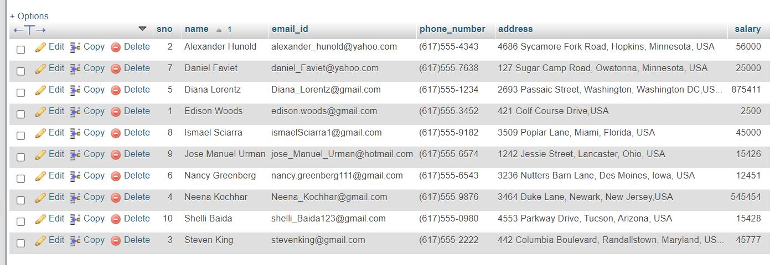

**b. for selecting users who's salary greater than 25000**

SELECT * FROM users_table WHERE salary>=25000 ORDER BY name ASC (This query show the information of all users which have salary greater than 25000)

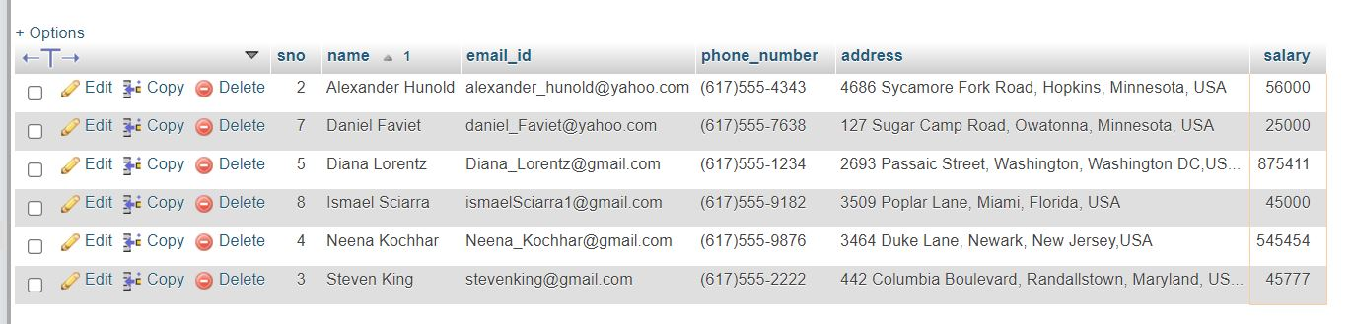

**c. Select the Average of all user salaries**

SELECT AVG(salary) as average FROM users_table (this query will return the average salary of all the users which are currently working in company)

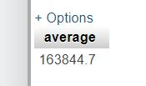

**d. Total Number of Users**

SELECT COUNT(sno) as total_user FROM users_table (This query return the total number of users which is currently working in the company)

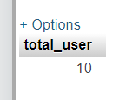

**e. Select the Total of all user salary**

SELECT SUM(salary) as Total_salary FROM users_table (This query return the total amount which is giving to his currently working employees)

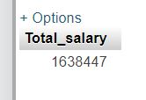

**2. Select query with joins**

**a. Select users according to the departments (**This query return all the information about the user in which he/she is currently working in the department**)**

SELECT u.*,d.* FROM user_department_table as ud INNER JOIN users_table as u ON u.sno=ud.user_id INNER JOIN department as d ON d.sri =ud.department_id ORDER BY u.name ASC

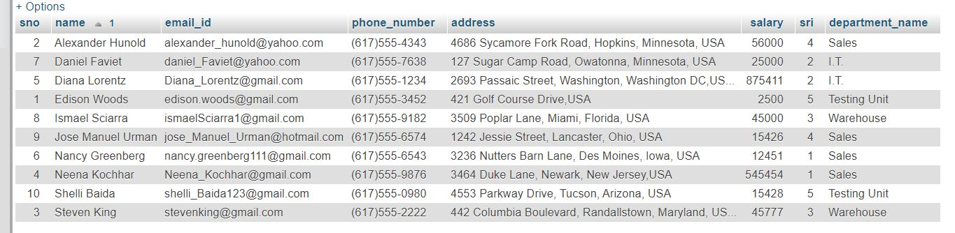

**b. Select users which belongs to sales department (**This query return all the information about the user in which he/she is currently working only in ‘Sales’ department**)**

SELECT u.*,d.* FROM user_department_table as ud INNER JOIN users_table as u ON u.sno=ud.user_id INNER JOIN department as d ON d.sri =ud.department_id WHERE d.department_name='Sales' ORDER BY u.name ASC

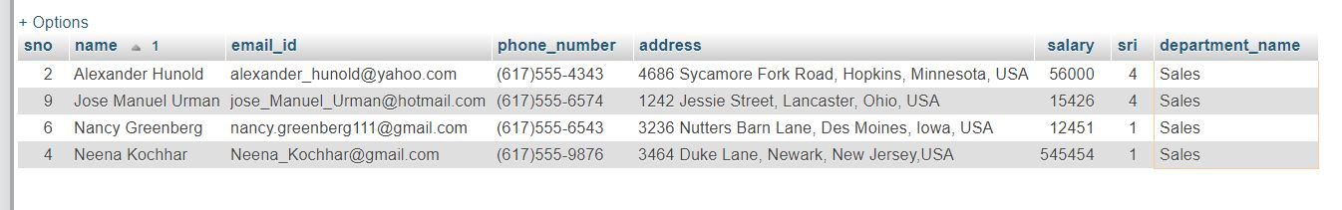

**c. SELECT users which belongs to Testing unit or Warehouse(**This query return all the information about the user in which he/she is currently working only in ‘Testing’ and ‘Warehouse’ department**)**

SELECT u.*,d.* FROM user_department_table as ud INNER JOIN users_table as u ON u.sno=ud.user_id INNER JOIN department as d ON d.sri =ud.department_id WHERE d.department_name IN('Testing Unit','Warehouse') ORDER BY u.name ASC

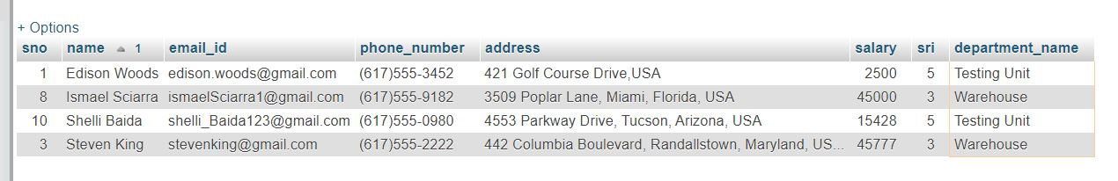

**d. Select devices which belongs to users (**This query return all Device information in the company and also giving the information that which device is assigned to the users)

SELECT u.*,d.* FROM user_device_table as ud INNER JOIN users_table as u ON u.sno=ud.user_id INNER JOIN device_table as d ON d.sno=ud.device_id ORDER BY u.name ASC

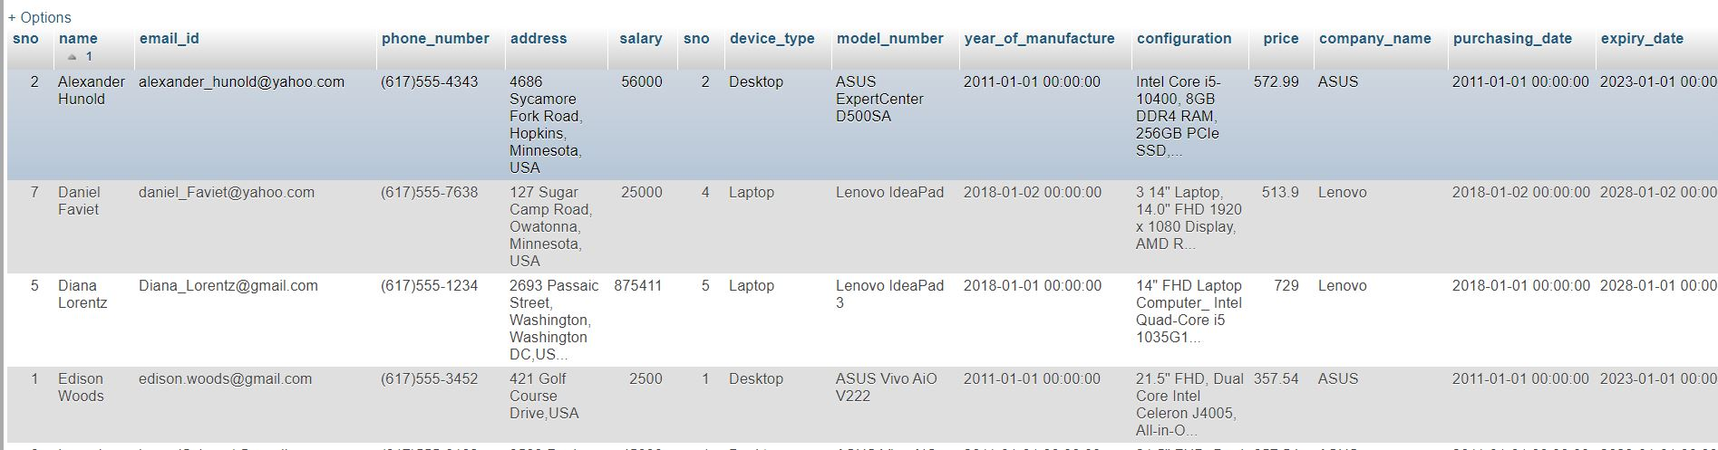

**e. Select software which is installed on Devices (**This query return all Device information in the company and also giving the information that what kind of software is installed on the device)

SELECT s.*,d.* FROM software_device_table as sd INNER JOIN software_table as s ON s.sno=sd.id INNER JOIN device_table as d ON d.sno=sd.device_id ORDER BY s.name ASC

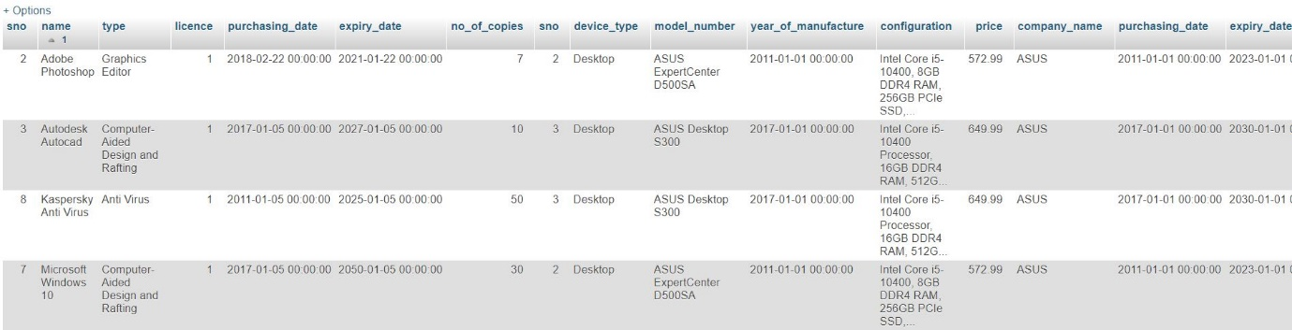

**f. Select Software which provided by vendors (**This query returns all vendor information from where the company has purchased the software and complete information of the software)

SELECT s.*,v.* FROM software_vendor_table as sv INNER JOIN software_table as s ON s.sno=sv.software_id INNER JOIN vendor_table as v ON v.sno=sv.vendor_id ORDER BY s.name ASC;

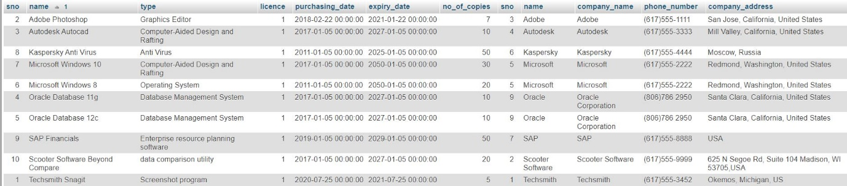

**3. Select Query with groups**

**a. No of users in each Department (**This query returns number of users which is working in particular department**)**

SELECT d.sri,d.department_name,count(ud.user_id) as Totalcount FROM user_department_table as ud INNER JOIN users_table as u ON u.sno=ud.user_id INNER JOIN department as d ON d.sri =ud.department_id GROUP BY ud.department_id ORDER BY d.sri ASC

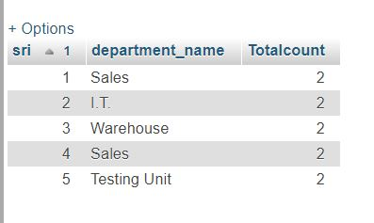

**b. No of user assign on each system (**This query returns number of users which are assigned on the particular Device**)**

SELECT d.sno,d.device_type,d.model_number,Count(u.sno) as total_count FROM user_device_table as ud INNER JOIN users_table as u ON u.sno=ud.user_id INNER JOIN device_table as d ON d.sno=ud.device_id GROUP BY d.sno ORDER BY d.sno ASC

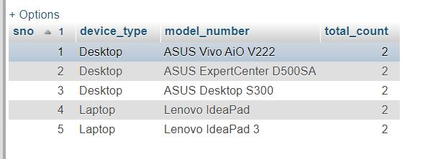

**c. No of user group of each department have sum of salary greater than 60000 (**This query returns Sum of users group salary according to the department and return only those groups which have the sum more than 60000 amount **)**

SELECT d.sri,d.department_name,count(ud.user_id) as Totalcount,SUM(u.salary) as salary_count FROM user_department_table as ud INNER JOIN users_table as u ON u.sno=ud.user_id INNER JOIN department as d ON d.sri =ud.department_id GROUP BY ud.department_id HAVING 60000<SUM(u.salary) ORDER BY d.sri ASC

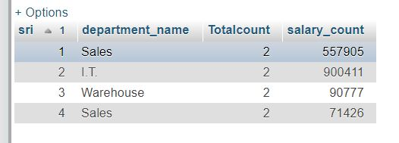

**d. System which has installed more than 2 software (**This query returns number of software which are installed more than 1 device**)**

SELECT d.device_type,d.model_number ,COUNT(sd.software_id) as total_count FROM software_device_table as sd INNER JOIN software_table as s ON s.sno=sd.id INNER JOIN device_table as d ON d.sno=sd.device_id GROUP BY sd.device_id HAVING COUNT(sd.software_id)>1 ORDER by d.device_type ASC;

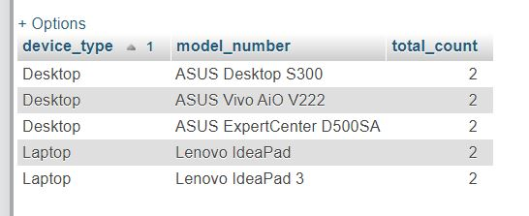

**4. Select Query with nested**

**a. Select users which salary has greater than average salary (**This query return those users which have salary greater than average salary in the company**)**

SELECT * FROM users_table WHERE salary > (SELECT AVG(salary) as average FROM users_table ) ORDER BY name ASC

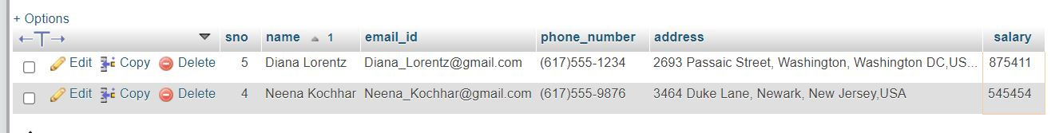

**b. Selecting Users which belongs to 'Testing unit' and ‘Warehouse’ (**This query returns all the information about the user in which he/she is currently working only in ‘Testing’ and ‘Warehouse’ department**)**

SELECT * FROM users_table WHERE sno IN(SELECT sno FROM user_department_table as ud INNER JOIN users_table as u ON u.sno=ud.user_id INNER JOIN department as d ON d.sri =ud.department_id WHERE d.department_name IN('Testing Unit', 'Warehouse') ORDER BY u.name ASC) ORDER BY name ASC

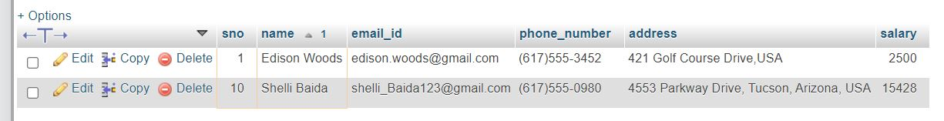

**c. Select software which have more than 10 years of validity (**This query returns all the software and software information which have more than 10 year validity or more than 10**)**

SELECT * FROM software_table WHERE sno in (SELECT sno DateDiff FROM software_table WHERE ROUND((DATEDIFF(expiry_date,purchasing_date)/365))>10) ORDER by name

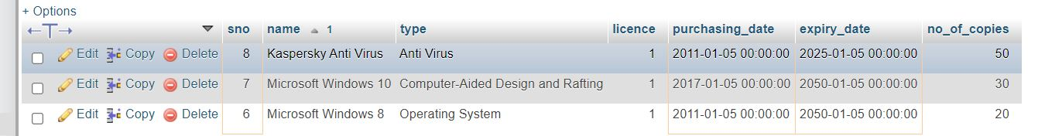

**d. Selecting those vendors whom does not include 'Oracle','SAP','Kaspersky' (**This query returns all software and the software information which don’t belongs to Oracle, SAP and Kaspersky **)**

SELECT * FROM vendor_table WHERE sno NOT IN (SELECT sno FROM vendor_table WHERE name IN ('Oracle','SAP','Kaspersky')) ORDER by name ASC

